VISION AWARENESS PATCH PROGRAM
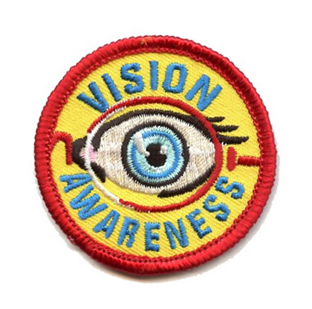
Suggested Activities For Your Troop
Visit a doctor of optometry’s office or have one come to your meeting. Locate an optometrist near you by visiting www.aoa.org/doctor-locator-search or calling the New York State Optometric Association at 518-449-7300.
Then, complete two activities below:
- Not everyone has 20/20 vision. Learn about nearsightedness, farsightedness and astigmatism and how glasses or contacts can help.

- Children often experience vision problems that are not easily detected. Learn how vision can affect school activities and how a doctor of optometry can help.

- The American Optometric Association’s National Save Your Vision Month is March. Make a poster for your school that promotes eye health and good vision practices.

- Learn about a career in optometry. What optometry schools are located in or near your state? How do you become licensed? What’s an average salary?

- Run an Eyeglass Donation Drive. Contact a local service organization that collects them. A suggestion is to visit https://lionsclubs.org/en/resources-for-members/resource-center/recycle-eyeglasses.

- Do “activities in the dark.” Divide the Scouts into pairs, having one scout put a blindfold on and the other be non-blindfolded. The blindfolded scout should try some basic activities such as buttoning or zipping a coat, tying shoes, writing, etc. The non-blindfolded scout should lead, explain what is seen and be a guide for safety purposes. Then trade roles. Discuss: How did it feel to not be able to see? How did you accomplish simple activities? What would you do if you met a blind person?
The American Optometric Association has activity sheets for younger children, as well as classroom exercises, on its website under “Resources for Teachers.” Other activities often of interest are optical illusions, making pinhole cameras, drawing and labeling parts of the eye, or demonstrating/observing how the pupil of the eye reacts in light and dark.

